

**Model Development Phase Template**

|  |  |
| --- | --- |
| Student Name | Pranay Bhandwalkar |
| Project Title | Uncovering The Hidden Treasures Of The  Mushroom Kingdom: A Classification  Analysis |
| Maximum Marks | 10 Marks |

**Initial Model Training Code, Model Validation and Evaluation Report**

**Initial Model Training Code**

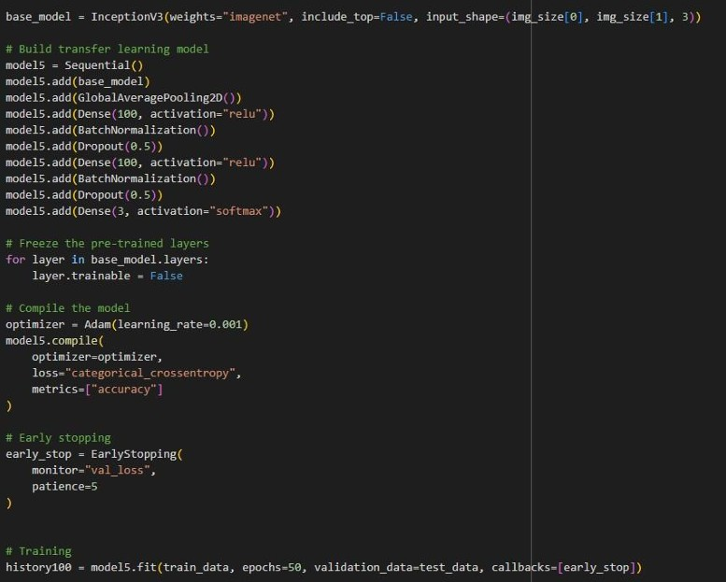



**Model Validation and Evaluation Report**

|  |  |  |
| --- | --- | --- |
| **Model** | **Summary** | **Training and Validation Performance**  **Metrics** |
| **Model 1**  (InceptionV3 +  Custom Layers) | **Layer Summary:**   * InceptionV3 base model * GlobalAveragePooling2D * Dense(100, relu) * BatchNormalization * Dropout(0.5) * Dense(3, softmax)     **Total Parameters:**  2,311,305  **Trainable Parameters:**  2,304,505  **Non-trainable**  **Parameters:** 6,800 | **Training Accuracy**: 83.42%  **Validation Accuracy**: 88.36%    Training converged well with slight overfitting mitigated by dropout and batch normalization. |